Student name: Zholshiyeva Arailym

ID: 190103028

Class: Web programming fundamentals (practice)

***Article 3***

Creating a responsive using bootstrap

1. *What is responsive?*

A responsive site is a site that adjusts to the size of the screen and looks good on both a large computer and a small phone.

*2. What is bootstrap?*

Bootstrap is a framework for building websites. It has many useful features: show pop-ups, display buttons and errors, draw drop-down menus, and much more.

What does it give us:

* You can create a beautiful site with a menu on the left, a main column in the center, and a field for advertising on the right. Or make a site with three, four, six columns - like Pinterest.
* You can teach the site columns to hide or resize depending on the screen size. For example, display side columns on a large screen, but not on a small one.
* You don't have to think too much about fonts, sizes and padding: even the standard Bootstrap setup already works pretty well.
* You don't need to think about how all this will behave on mobile devices - everything adapts itself.

*3. How to connect it to site?*

To use Bootstrap on a page, you need to write such a command, its recommends using the official website of the engine:

<link rel="stylesheet" href="https://stackpath.bootstrapcdn.com/bootstrap/4.3.1/css/bootstrap.min.css" integrity="sha384-ggOyR0iXCbMQv3Xipma34MD+dH/1fQ784/j6cY/iJTQUOhcWr7x9JvoRxT2MZw1T" crossorigin="anonymous">

This command downloads the base version of Bootstrap from an external server where this code is officially stored. You can, of course, download your own version of Bootstrap and put it on your site, but using an external site is more convenient in our case. The command should be inserted in the **<head>** section, for example, after the meta properties.

*4. Title?*

Let's start simple. The first thing we need is the title of the entire page. We will make it a separate block so that nothing will interfere with it. We will place all the code inside the **<body>** section:

The first block - **"container"** - tells Bootstrap that the layout of the site will now take place here. There can be as many containers on the site as you like, they will stand one below the other.

The second block - **"row"** - means that a row of 12 columns has started. It is necessary to nest such a row in the container, several can be. Imagine this is a table row.

The third block is responsible for the cells in the row. We've now told the browser to select 12 cells for the title regardless of the screen size. At the same time, the title will not be stretched to the full width - it will take up as much space as it would have taken in a normal layout.

*5. Adjusting the size of pictures.*

To make the pictures look good on different screens, let's make sure that on medium screens all cats are of the same size, and on small screens they line up one under the other. To do this, let's change our previous block in this way:

</div>

<div class="row">

<div class="col-12 col-sm-12 col-md-4 col-lg-2 col-xl-2">

<img src="http://thecode.local/wp-content/uploads/2019/06/cat1.jpg">

</div>

 <div class="col-12 col-sm-12 col-md-4 col-lg-8 col-xl-8">

<img src="http://thecode.local/wp-content/uploads/2019/06/cat2.jpg">

</div> <div class="col-12 col-sm-12 col-md-4 col-lg-2 col-xl-2">

<img src="http://thecode.local/wp-content/uploads/2019/06/anton-kraev-1166716-unsplash.jpg"> </div>

</div>

For each picture, we have added a description of the block sizes for each screen size and will analyze it using the example of the first picture. Now, if the screen is very small (col) or just small (col-sm), then the first block with a cat will occupy all 12 cells, that is, the entire width. If the screen is medium-sized (col-md), then 4 cells, and if it is large (col-lg) or very large (col-xl), then let the cat occupy 2 cells.

For the second picture, the same rules apply, but the size of the cat on large and very large screens is different - 8 cells. The third picture is configured in the same way as the first. Please note: in order to get the same size of pictures on medium screens, we added the same command col-md-4 to the description of each of them, which gives each cat 4 columns so that all are of the same size.

This is what happened in the end - we did not program all the calculations of the screen size, fit the images to them, did not constantly ask if the size changed - Bootstrap did everything for us. We just told him what size we want to see each block, and that's it - then the magic of the framework worked!

This is how the finished code looks like:

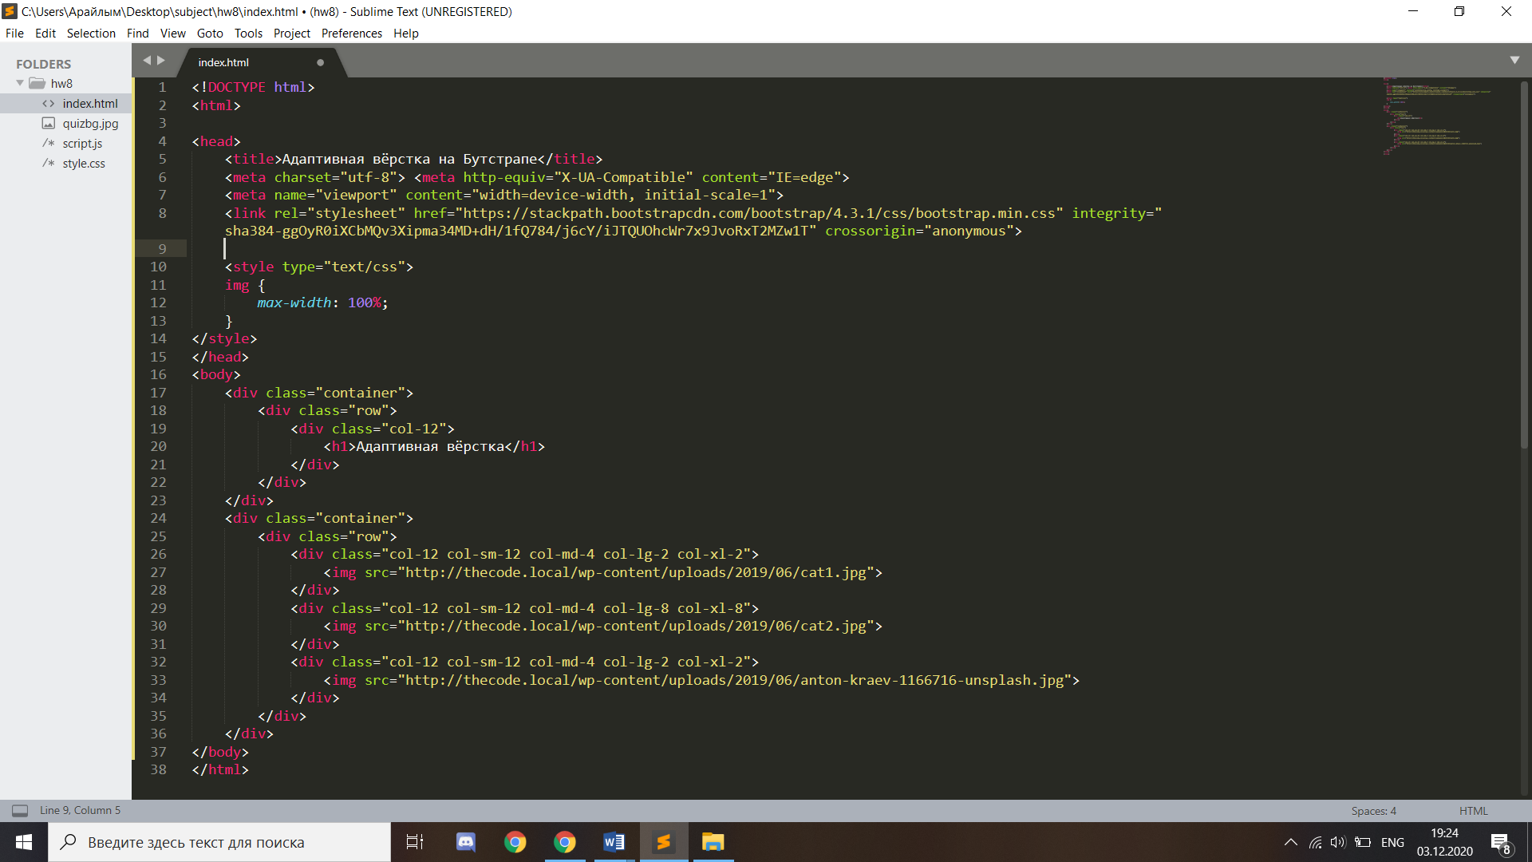

Sources: <https://thecode.media/bootstrap/>